INFOLABZ IT SERVICES PVT. LTD.

**Course :** React

**Session No :**

**Topics to be covered :** Node Js Installation , Step by Step react project development, Functional Components in react

**Required Tools / Installation :**

1. Download Nodejs ( search in google )

Link : <https://nodejs.org/en/download>

1. Install Node.Js
2. Download Visual Studio Code ( Recommended )

Link : <https://code.visualstudio.com/download>

**Creating First react project :**

1. Create a folder “reactprojects” in any drive ( For example : D drive )

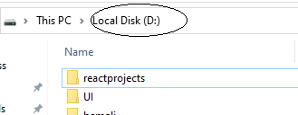

1. Open command prompt ( win+r, and type cmd )

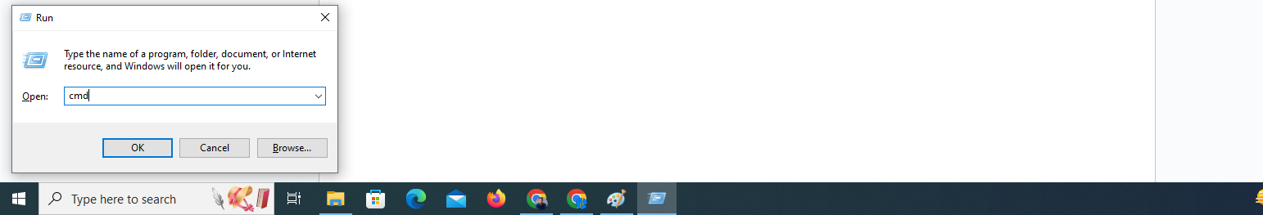

1. Go to D Drive

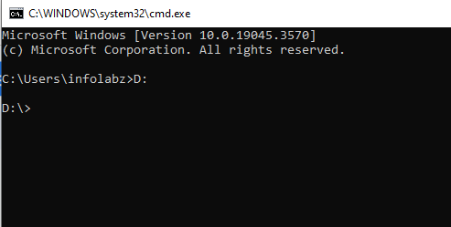

1. Go to specific folder “reactprojects”

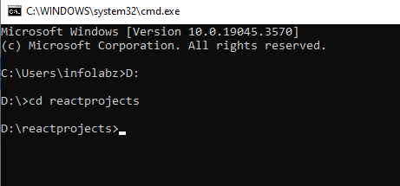

1. Create a new project ( Enter following command )

npm init react-app first

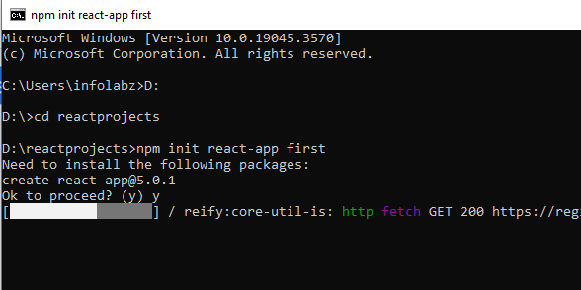

Project created successfully.

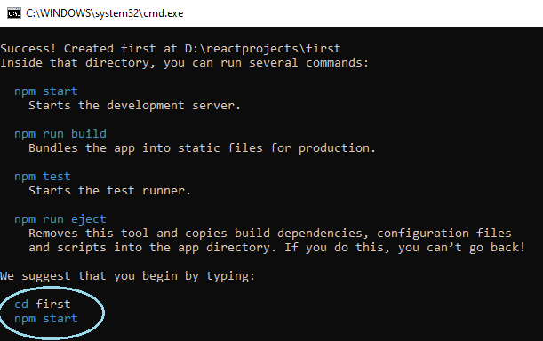

1. Go to project folder

cd first

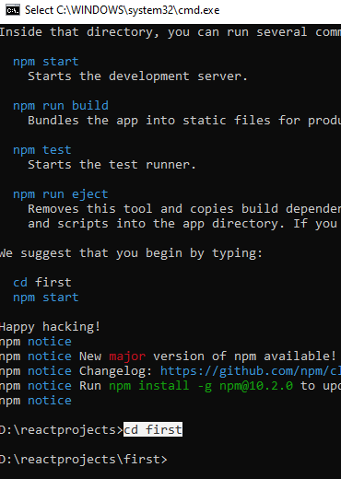

1. Run Project

npm start

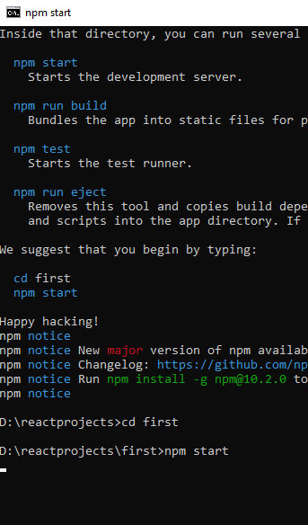

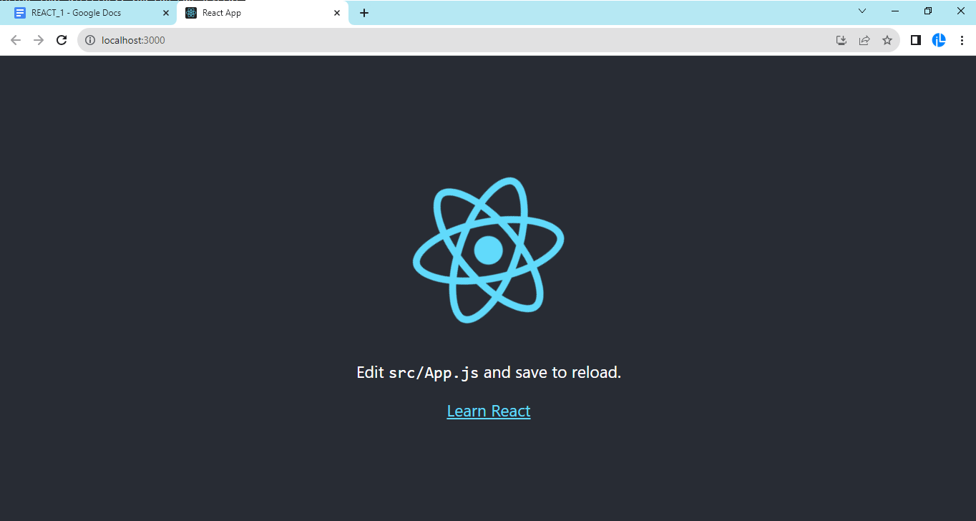

**STRUCTURE :**

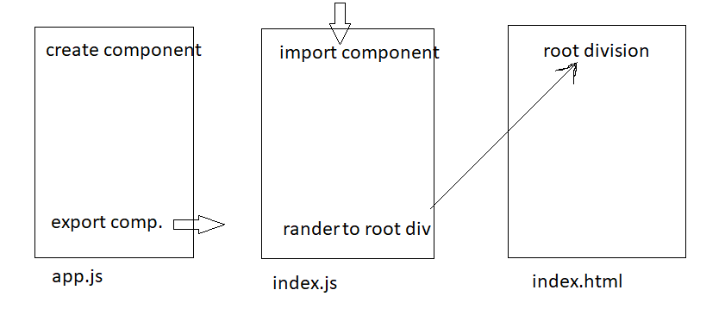

**Note :** There are two types of components

* 1. Functional Components b) Class Components

Create a new project : **functionalcomponent**

npm init react-app functionalcomponent

**Load project in visualstudiocode (VS CODE )**

File > Open Folder > D: > Click on reactprojects > Click on first

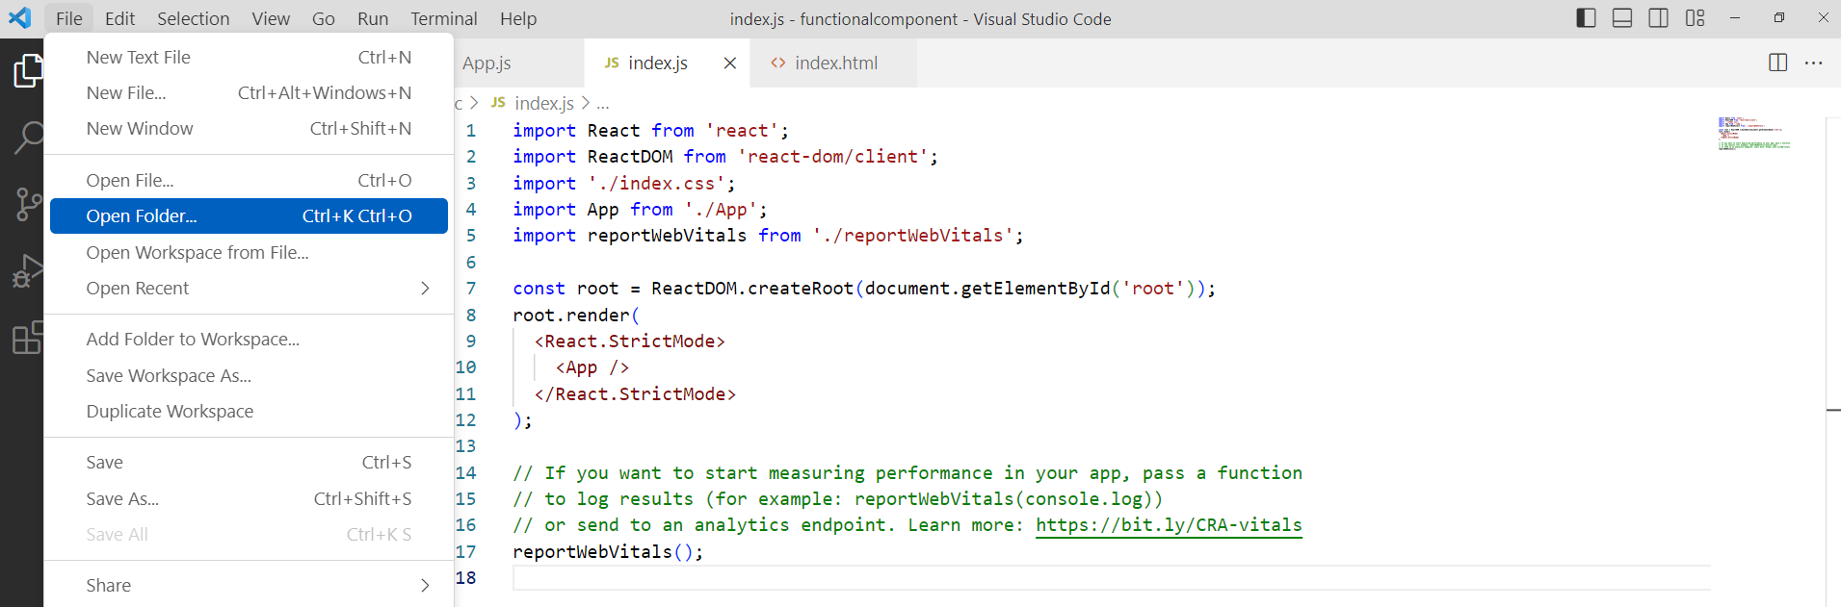

**Note** :

App.js : Create Component and Export it

Index.js : Import Component and Render it to root ( index.html )

**Note :**

1. First latter of the component should be in capital

For example : App, First, Second , Third etc

1. First component is exported as default component

export default App

1. Remaining other components are exported as

export {First,Second,Third}

App.js ( Created a component named App and Exported as default as it is first component )

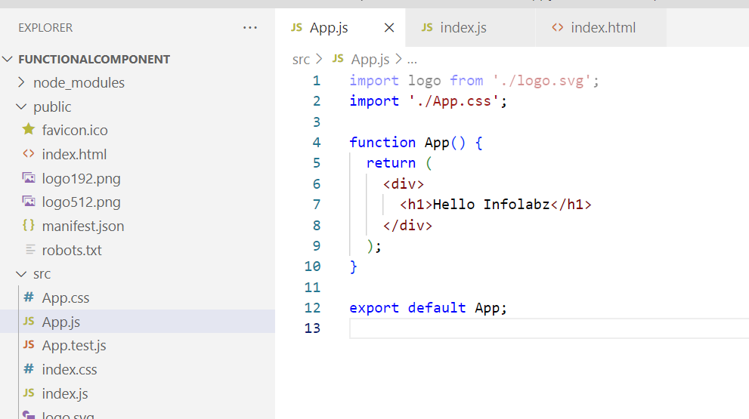

Index.js ( import component App and render it to root / index.html )

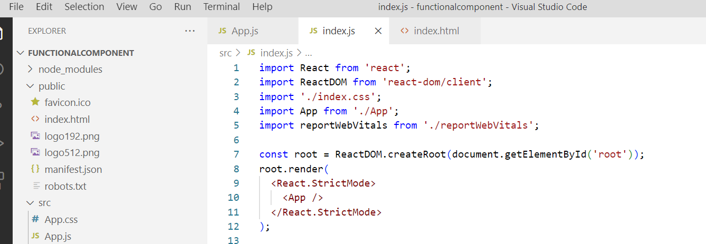

Output :

( Run project if stopped. Step 7 as above )

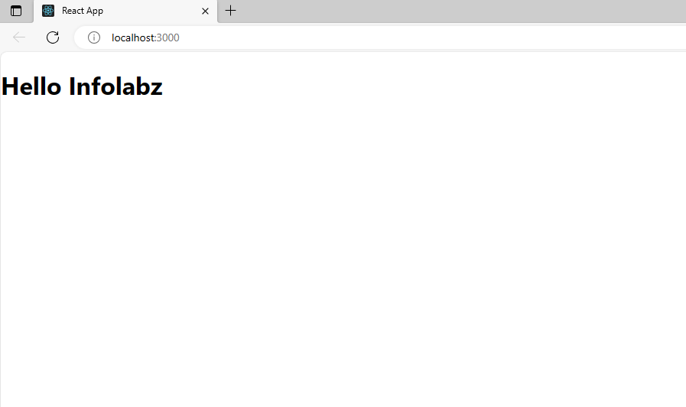

Create Two more components in same project: First & Second

**App.js**

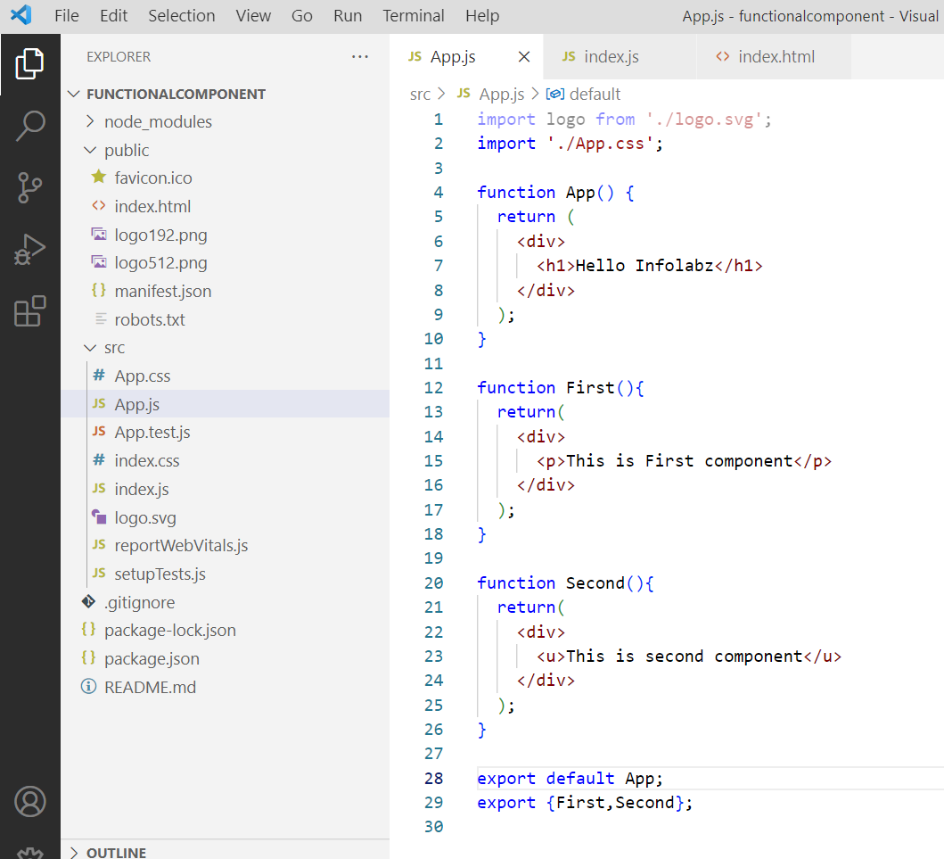

**Index.js**

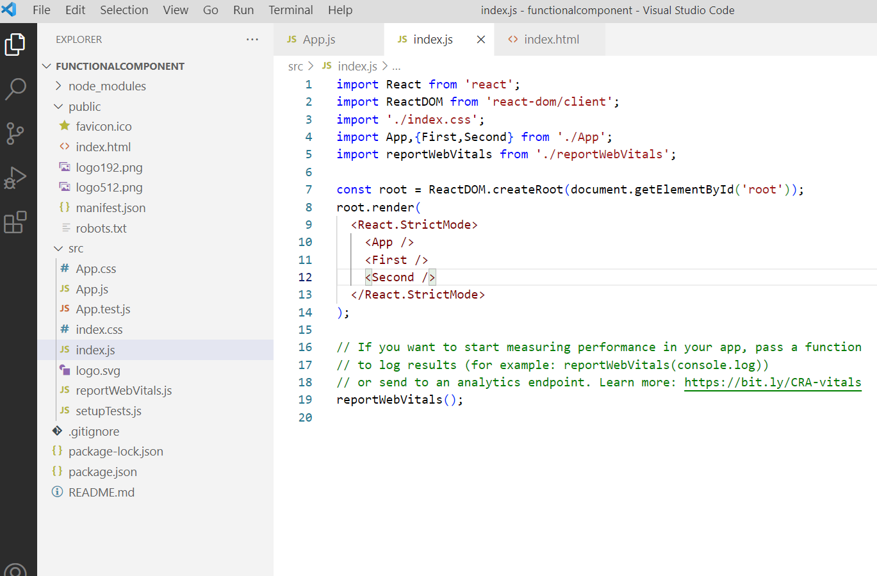

**OUTPUT :**

